Ch21 – World War I, 1914-1918

Imperialism - Policy of extending the rule or authority of an empire or nation over foreign countries, or of acquiring and holding colonies and dependencies.

Laissez-faire - From the French, laissez-faire literally means "to let (people) do (as they choose)." As an economic doctrine, laissez-faire opposes government interference in economic and business matters, or at least desires to keep government's role to an absolute minimum.

Nationalism - Loyalty and devotion to a nation.

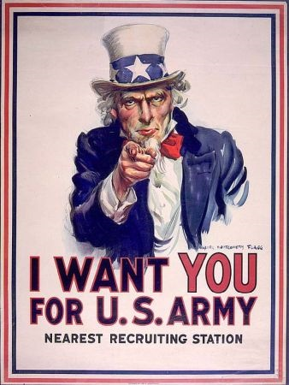
Introduction
- US involvement only lasted 19 months
- US economy temporarily controlled by Washington
- Set the stage to impose on economy in 1930’s
Origins of WWI
- Nationalistic and Imperialistic rivalries
- France: revenge for lost territory and reparations to Germany from the Franco-Prussian War of 1870-1871
- Austria-Hungary: feared the restive Slavic minorities that were increasing
- Germany: feared being surrounded by hostile military alliances
- The assassination in Serbia of Austrian Archduke Ferdinand & his wife (Heir to Austro-Hungarian throne) by Serbian revolutionary on June 28, 1914
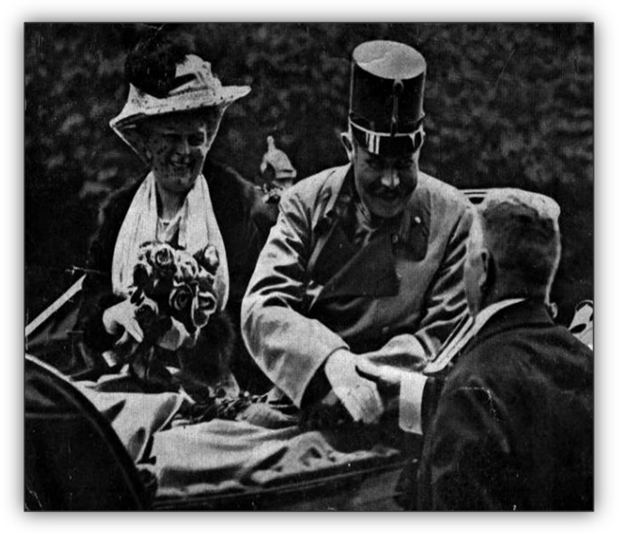
European Arms Race
- Numerous alliances & treaties in Europe

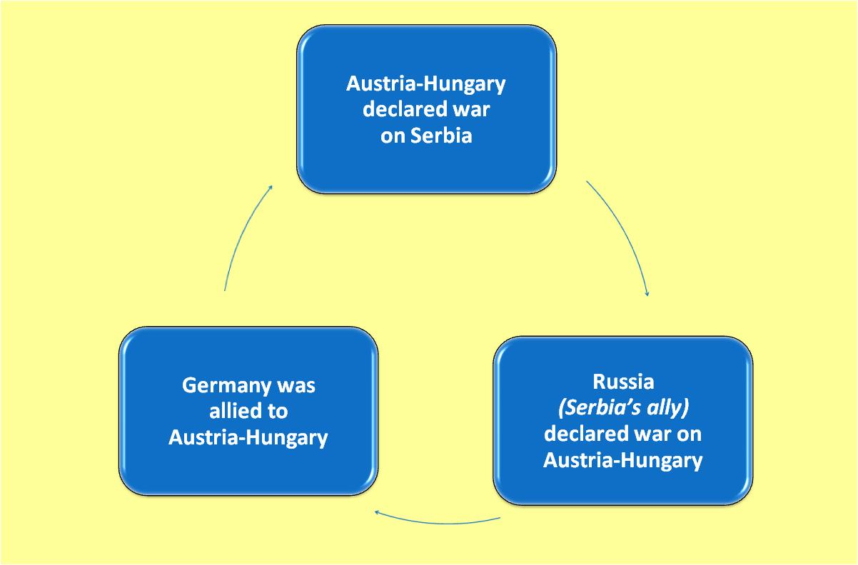

Archduke Ferdinand & his wife

- Combatants
    - Allies - Great Britain, France, Russia, Italy, Arabs, and other small countries and later the US (in April 17, 1917)
    - Central Powers - Germany, Austria-Hungary & Turkey
Why did the US join the Allies?
- Cultural and linguistic ties to Great Britain
- Germany’s use of submarines against the US
- Germany sunk the British ship Lusitania which killed 124 Americans
- At the urgings of Pres. Wilson Germany stopped for awhile and then in early 1917 started unrestricted submarine warfare again
Reaction in US
- Initially a financial panic
- NYSE closed for 6 months
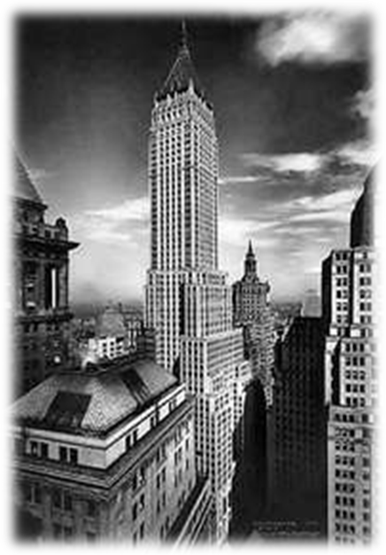
- US was in recession in 1914
- When the war began the US was a debtor nation (the normal status for a developing country)
- In 4 years of war:
    - US economy grew by 21%
    - US went from $3.7 billion in debt overseas to $12.6 billion as a creditor
- When the war finished the US was a creditor that held much of the world’s stock of monetary gold
  - Allies paid US with gold although US officially neutral
- Before the war London, England was the financial center – after the war New York was the world’s financial center
- US supplied Allies
  - Agricultural products
  - Munitions - DuPont supplied 40% of Allied needs
During World War I
Woodrow Wilson was the US President in office during World War I
The armed forces increased from about 180,000 to 3 million
Military draft was instituted, with a system of deferments for skilled workers
117,000 Americans died in military service (more than ½ from diseases)
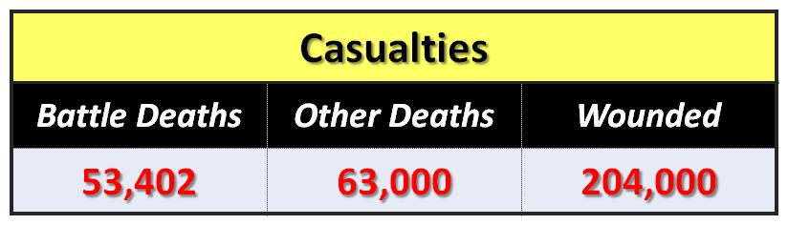
The US produced large amounts of arms, weapons, airplanes (new for war), and a great ship-building program
The US was a formal participant in the war for only 19 months
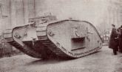
April 17, 1917 → November 11, 1918
European nations purchased large quantities of munitions and food at ever-rising prices form the U.S.
The gap between Europe’s imports from the U.S. and exports to the US rose dramatically
The war was immensely profitable for many U.S. corporations
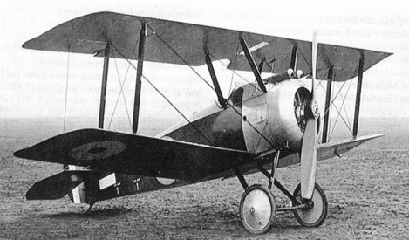
Between 1914 and 1920, the US price level nearly doubled
Both nominal and real earnings increased substantially
In 1917 money incomes increased by 14.5% from 1916 but consumer prices increased by 16.1% → real wages fell
Reasons wages in the US increased during World War I:
A sharp decrease in immigration during the war
A large increase in drafting men into the armed forces
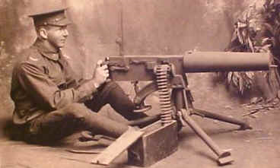
A large increase in the number of government contracts
Many new agencies were started to regulate prices
Provided a precedent for the federal government’s increased role in the economy
Attempts were made to direct the economy from the top down
- The War Industries Board
- The Food and Fuel Administrations
Government increased spending for 1.5% of GNP in 1916 to 24.2% in 1918
Labor During The War
Unemployment was at 5.1% in 1916
US experienced nearly full-employment
Therefore to increase consumption of weapons and other military supplies required a reduction in civilian investment and consumption
Demand for workers increased because of the federal war contracts but labor supply was down due to military draft & limits on immigration
Strikes:
In 1917 set a record for the most strikes = 4,450
Especially bad west of the Mississippi
Federal Responses:
Threat of drafting strikers
Require federal contracts with higher wages, better working conditions but not “closed shops”
When the railroad workers threatened a strike Wilson nationalized the Railroads
Resulted in better working conditions
Returned to private ownership in 1920
Women
Source of labor during the war
After the war they were asked to make room for returning veterans
19th Amendment to the Constitution = Women suffrage (the right to vote) in 1920
African Americans
Gained a lot
By 1914 Northern industries fanned out across the South to recruit workers
Created violent race riots (St. Louis 1917 and Chicago 1919)
Provided a way to “get a foot in the door”
Costs of the War
Was about $31 billion
44% of average GDP during the war period 1917-1920
Equivalent to $6 trillion in today’s dollars
Major part of the war’s cost was borne by the soldiers, sailors, airmen, and their families
117,000 soldiers died and 204,000 were wounded
- discounted value of the lost future income
Psychological costs – shell shock and disillusionment with American life and culture → “Lost Generation”
The draft = a tax: the difference btwn what the government would have had to pay a soldier to get him to volunteer for military service vs what they actually paid
Financing the War
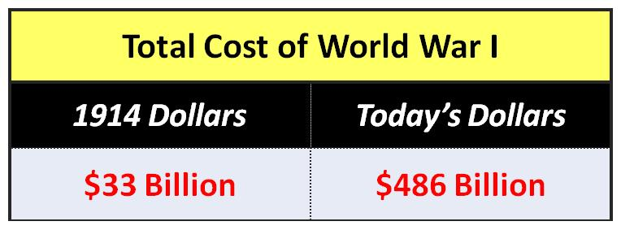
Financing World War I 1917-1919
 | Total (Billions) | Percent
War Expenditures | $ 31.0 | 100%
Taxes | 7.6 | 24.5
Borrowing from the Public | 19.0 | 61.4
Creating New Money | 4.4 | 14.1
How we paid for WW I: (* = most popular ways)
- Commandeering (including drafting soldiers and confiscating food and other raw materials)
- Capturing resources from the enemy
- Receiving voluntary contributions from citizens or allies
- Selling existing land owned by the government
- * Taxes were increased
  - Estate taxes instituted in 1916
    - Help finance rearmament
    - Became a permanent but small part of the federal revenue system
  - War Revenue Act of 1917
    - Raised personal & business income taxes (top bracket was 70%!)
- Income taxes became permanent part of federal financing
    - Established excise taxes, excess profit taxes (for businesses), and luxury taxes
- * Borrowing - Borrowing was largest financing mechanism
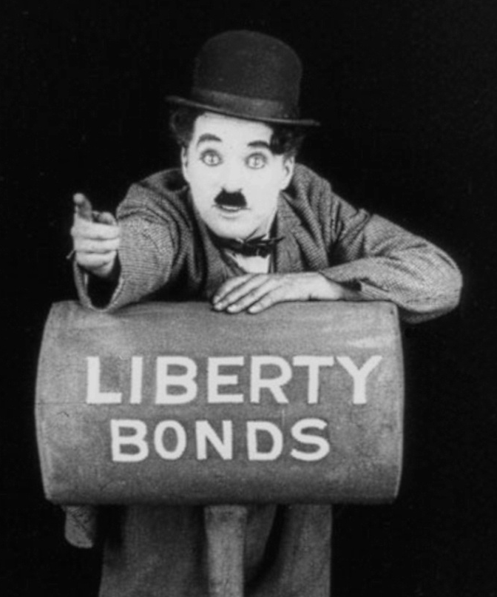
  - Liberty Bonds
  - Preferred method bc it concealed some of the costs of the war
  - Billions of dollars worth of bonds were sold to the public “capitalize patriotism”
    - Huge bond rallies were held
    - Silent Movie Stars / Celebrities pushed the bonds
      - Ex. Charlie Chaplin made a film showing how the purchase of war bonds helped finance the war
  - The national debt was expanded from 3 percent of GDP at the beginning of the war to 32 percent of GDP by the end of the war
- * Printing money
  - During the Revolutionary War the government printed Continental Dollars
  - During the Civil War the government printed Greenbacks
  - The money supply was expanded via the Federal Reserve buying bonds
    - 1914-1920 - Federal Reserve doubled the money supply resulting in inflation of nearly 200%
    - Inflation due to money creation is popular bc it is a hidden tax

Year | Stock of Money  (US $ billions) | Money per unit of Real NNP  (1914=100) | Prices implicit NNP Deflator  (1914=100)
1914 | $16.39 | 100 | 100.0
1915 | 17.59 | 104.1 | 103.1
1016 | 20.85 | 105.2 | 116.5
1917 | 24.37 | 126.3 | 143.9
1918 | 26.73 | 126.1 | 165.5
1919 | 31.01 | 140.5 | 168.0
1920 | 34.80 | 166.0 | 191.7

Replacement of Market Economy with Command Economy during War
- Washington determined what would be produced not the market
- Moved away from laissez-faire to government direction
- Germany had a command economy
- US Railroads nationalized -- Controlled by government
- Large expansion of new federal government agencies (over 150) & expanded powers to existing agencies
Food & Fuel Administrations
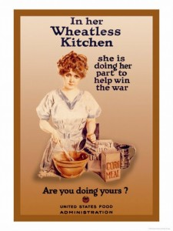
- Food Administration - Headed by Herbert Hoover
- Maintain an adequate supply of food to the domestic market and to our allies while preventing excessive increases in prices
- Wanted voluntary cooperation
  - “Meatless Mondays” and “Wheatless Wednesdays”
    - Promoted to reduce domestic demand and leave more for exports
  - Victory Bread
    - Wheat floor was mixed with rye or potato flour for loaves of bread
  - Direct control of prices (with penalties for violation) were avoided
  - Formal rationing was avoided – except for sugar
- Fuel Administration - Headed by Harry Garfield
  - To assure adequate coal supply to country
- War Industries Board in 1918- Headed by Bernard Baruch
  - Negotiating prices of key industrial raw materials
  - Other industrial prices were set by a separate Price-Fixing Committee (under The War Industries Board)
  - Developing and implementing the bulkline pricing system
    - A system of fixing prices sufficiently high to cover the costs of marginal producers so as to stimulate production
  - Establishing a ratings system for government contracts
    - Each contract was given a government priority rating: AA, A, B, C, D – orders were to be filled based on priority (AA 1st)
    - The unintended consequence of the "priorities inflation" of contracts
Legacies of WWI
Peace Treaty of Versailles ending WWI
President Wilson participated in Treaty negotiations (Wilson’s 14 Points)
At the end of World War I, the Treaty of Versailles outlined in broad terms the territorial adjustments that should occur in Europe, the extent of the reparations the losing nations owed, and the general association of nations that would guarantee each nation’s sovereignty in the future.
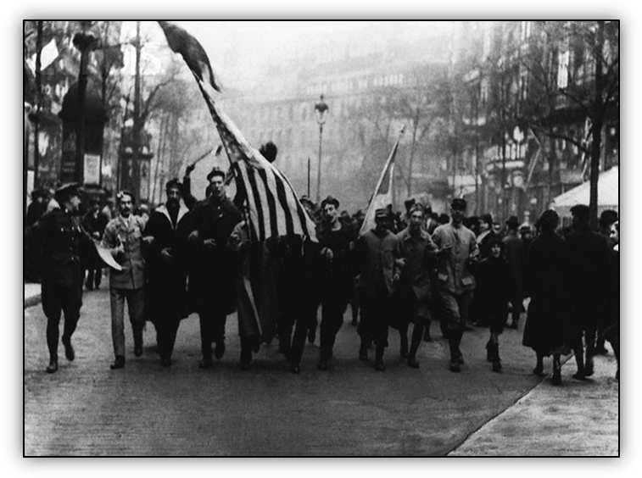
Treaty was to punish Germany & Austria-Hungary
Treaty adopted 4 of President Wilson’s 14 Points:
- Territorial Adjustments
- Imposed War Reparations on Germany & Austria-Hungary
- Guarantees of National Sovereignty
- Creation of Association of Nations called “League of Nations” in Geneva, Switzerland
Big Four: Britain, France, Italy, and the US
Created the Treaty of Versailles
Not ratified by the US
Celebrating the end of WWI in Paris
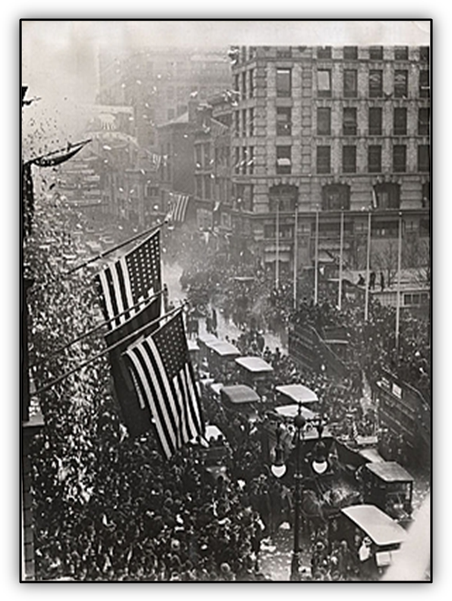
Germany was forced to:
Admit responsibility for the war
Transfer land and other resources to the allies
Pay reparations that were later set at $56 billion in gold dollars
Eccles and Keynes both said that the treaty was punitive and imposed excessive penalties on Germany and Austria and that they would never be able to repay it → led to WWII
Domestic Legacies
- During the post war period:
An economic slowdown occurred immediately following the Armistice
A vigorous boom began in 1919 → leading to the “Roaring Twenties”
The Federal Reserve followed a policy of keeping its discount rate below market rates
Celebrating the end of WWI in New York
- Financial
Increased federal spending for interest on the national debt, veteran’s benefits, and other long-term costs
- Ideologies
Role of government- could be large without negative effects
- War contracts ended, federal bureaus closed, demobilization of military, soldiers/sailors returned home
- US now leading creditor - NYC now the world’s financial center
- US gained markets in Latin America & Asia formerly served by Europeans

Woodrow Wilson, The Fourteen Points (1918)
http://www.pinzler.com/ushistory/fourpointssupp.html
The Fourteen Points was a speech given by United States President Woodrow Wilson to a joint session of Congress on January 8, 1918. The address was intended to assure the country that the Great War was being fought for a moral cause and for postwar peace in Europe and as a basis for ending World War I and for keeping the peace thereafter. Clearly one goal of the points was to address many of the factors that promoted the beginning of the World War in Europe and to establish a basis for a more peaceful world; in this sense Wilson hoped World War I would be a "war to end all war." The speech was delivered 10 months before the Armistice with Germany and became the basis for the terms of the German surrender, as negotiated at the Paris Peace Conference in 1919. However, only six points were put into effect as Wilson had intended. These were 7, 8, 10, 11, 13, and 14. The 14th point led to establishment of the League of Nations.
I. Open covenants of peace, openly arrived at, after which there shall be no private international understandings of any kind... diplomacy shall proceed always frankly and in the public view.

II. Absolute freedom of navigation upon the seas... alike in peace and war....

III. The removal... of all economic barriers and the establishment of an equality of trade conditions among all the nations.

IV. Adequate guarantees... that national armaments will be reduced to the lowest point consistent with domestic safety.

V. A free, open-minded, and absolutely impartial adjustment of all colonial claims, based upon a strict observance of the principle that in determining all such questions of sovereignty the interests of the populations concerned must have equal weight with the equitable claims of the government whose title is to be determined....

VI. The evacuation of all Russian territory and such a settlement of all question affecting Russia as will secure the best and freest cooperation of the other nations of the world in obtaining for her an... opportunity for the independent determination of her own political development....

VII. Belgium... must be evacuated and restored, without any attempt to limit the sovereignty which she enjoys....

VIII. All French territory should be freed and the invaded portions restored, and the wrong done to France by Prussia [Germany] in 1871 in the matter of Alsace-Lorraine, which has unsettled the peace of the world for nearly fifty years, should be righted....

IX. A readjustment of the frontiers of Italy... along clearly recognizable lines of nationality.

X. The peoples of Austria-Hungary, whose place among the nations we wish to see safeguarded and assured, should be accorded the freest opportunity of autonomous development.

XI. Rumania, Serbia and Montenegro should be evacuated; occupied territory restored... the relations of the several Balkan states to one another determined by friendly consul along historically established lines of allegiance and nationality; and international guarantees of the political and economic independence and territorial integrity of the several Balkan states....

XII. The Turkish portions of the Ottoman Empire should be assured a secure sovereignty, but the other nationalities which are now under Turkish rule should be assured an undoubted security of life and an absolutely unmolested opportunity of autonomous development....

XIII. An independent Polish state should be erected which should include the territories inhabited by indisputably Polish populations... whose political and economic independence and territorial integrity should be guaranteed....

XIV. A general association of nations must be formed under specific covenant for the purpose of affording mutual guarantees of political independence and territorial integrity to great and small states alike.

